cnc_download4

声明
/* download NC program 4 */
[DllImport("FWLIB32.dll", EntryPoint = "cnc_download4")]
public static extern short cnc_download4(ushort FlibHndl, ref int a, [In, MarshalAs(UnmanagedType.AsAny)] Object b);

描述
程序传输：从计算机到CNC。
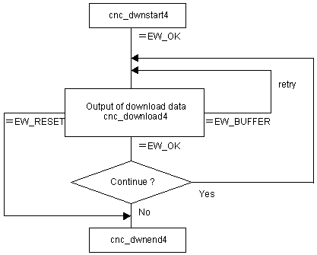

参数
（1）FlibHndl 库句柄；[ in ]
（2）length 长度 [ in/out ]
（3）data 程序 [ out ]

函数返回值
函数运行正常返回EW_OK。
Return code | Meaning/Error handling
EW_RESET  (-2) | Reset or stop request  CNC required to stop downloading.  Call the cnc_dwnend4 function.
EW_FUNC  (1) | cnc_dwnstart4 function has not been executed.
EW_LENGTH  (2) | The size of character string is zero or negative.
EW_DATA  (5) | Data error  In order to get more information for this err_no return value, execute cnc_getdtailerr function.  The following detail status will be set onto the member, err_no of ODBERR structure.  See Description about the timing of error.
  1 | : | A character which is unavailable for NC program is detected.
  2 | : | When TV check is effective, a block which includes odd number of characters (including 'LF' at the end of the block) is detected.
  3 | : | The registered program count is full.
  4 | : | The same program number has already been registered.
  5 | : | The same program number is selected on CNC.
EW_PROT  (7) | Write protected on CNC side  Tape memory is write-protected by the CNC parameter setting(O8000-/O9000- protection, encoding).  See Description about the timing of error.
EW_OVRFLOW  (8) | Memory overflow  CNC tape memory shorts for the registration.  Make enough free area in CNC memory.  See Description about the timing of error.
EW_BUFFER  (10) | Buffer full  Retry because the buffer is full.  See Description about the timing of error.
EW_REJECT  (13) | CNC execution denied  Downloading is disable in the current CNC status.  (Machining, resetting, mode changing)  See Description about the timing of error.
EW_ALARM  (15) | Alarm state  Alarm has occurred while downloading.  See Description about the timing of error.

代码
class Program
{
static void Main(string[] args)
{
ushort Flibhndl = 0;

short ret; // 返回值

// 获取库句柄 ( Ethernet )
ret = Focas1.cnc_allclibhndl3("192.168.0.224", 8193, 10, out Flibhndl);
if (ret != Focas1.EW_OK)
{
Console.WriteLine("发生异常，请检查！");
return;
}

#region cnc_download4

string prg = "\nO1234\nM3 S1200\nG0 Z0\nG0 X0 Y0\nG1 F500 X120. Y-30.\nM30\n%";
int len = 0;
int n = 0;

ret = Focas1.cnc_dwnstart4(Flibhndl, 0, "//CNC_MEM/USER/PATH1/");
if (ret != Focas1.EW_OK) return;

len = prg.Length;
while (len > 0)
{
n = len;
ret = Focas1.cnc_download4(Flibhndl, ref n, prg);
if (ret == (short)Focas1.focas_ret.EW_BUFFER)
{
continue;
}
if (ret == Focas1.EW_OK)
{
prg += n;
len -= n;
}
if (ret != Focas1.EW_OK)
{
break;
}
}
ret = Focas1.cnc_dwnend4(Flibhndl);

#endregion
}
}

